Deploy into AWS Lambda

**1. create asp.net core webapi project.**

**## Steps**

**1. Create ASP.NET Core Web API project.**

**2. Install `Amazon.Lambda.AspNetCoreServer.Hosting` NuGet package.**

**3. Add a call to `AddAWSLambdaHosting`method when services are defined in your application.**

**```csharp**

**// Add AWS Lambda support.**

**builder.Services.AddAWSLambdaHosting(LambdaEventSource.HttpApi);**

**var app = builder.Build();**

**```**

**Read more [Introducing the .NET 6 runtime for AWS Lambda](https://aws.amazon.com/blogs/compute/introducing-the-net-6-runtime-for-aws-lambda/)**

**4. Open `.csproj` file and add the following tag in the **PropertyGroup** section.**

**```xml**

**<AWSProjectType>Lambda</AWSProjectType>**

**```**

**5. Now, You’re done with the API stuff for this demo.**

**6. Create Lambda function in AWS Console.**

**7. Deploy to AWS, when deploying, keep the function handler name the same as Assembly Name.**

**Open into by clicking right – of your project StudentThreeTier**

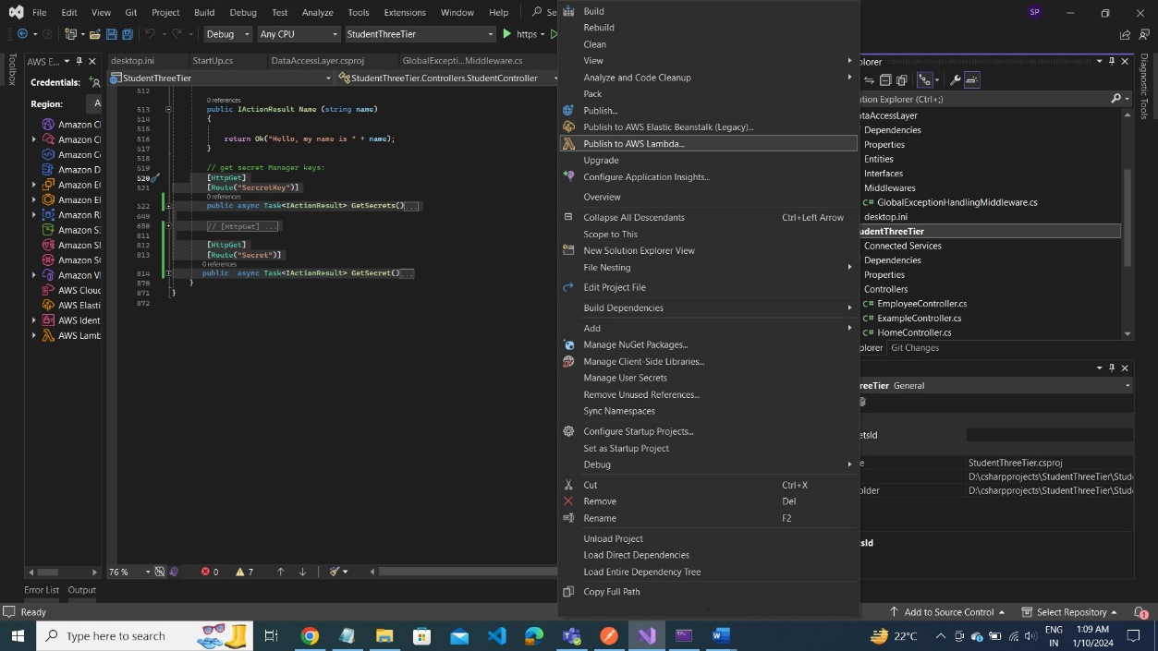

Upload lambda function here

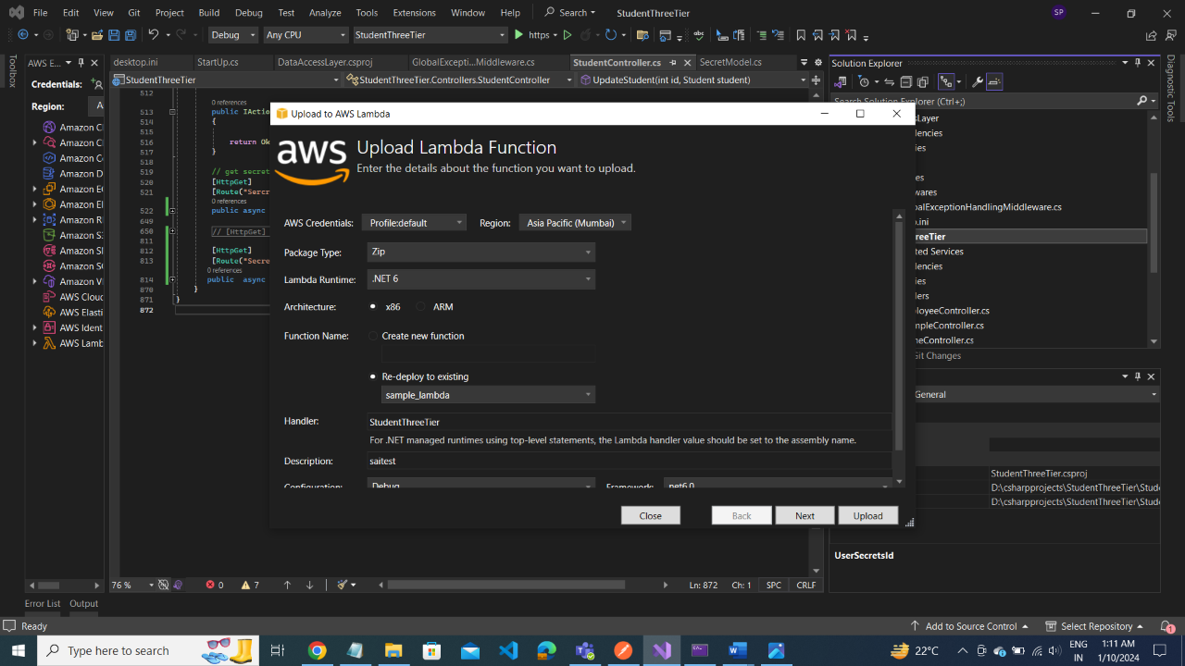

Step3 and step4 next -- upload

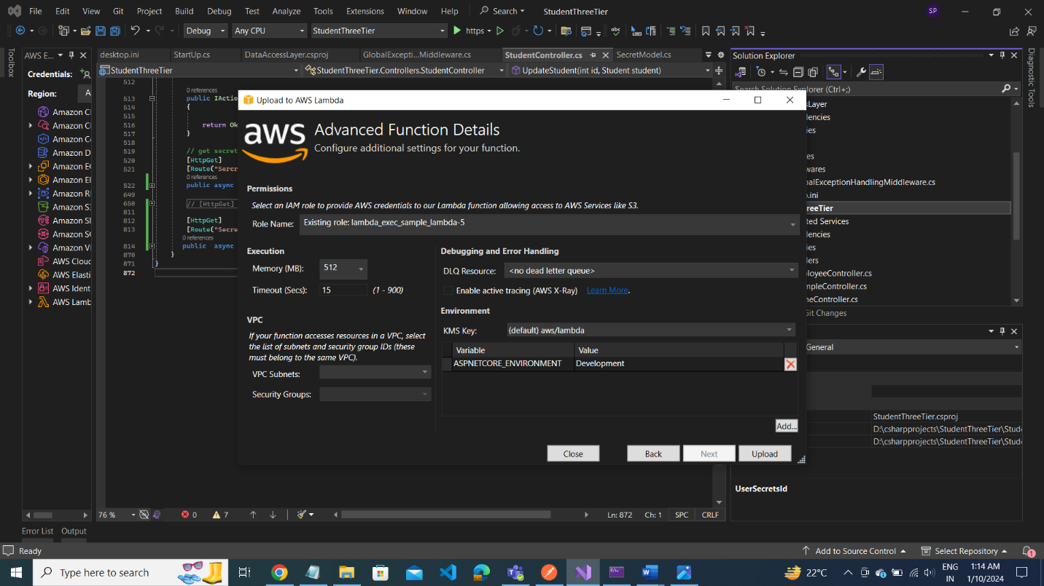

**Create Lambda Function:**

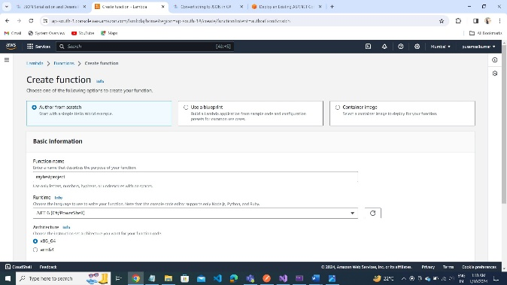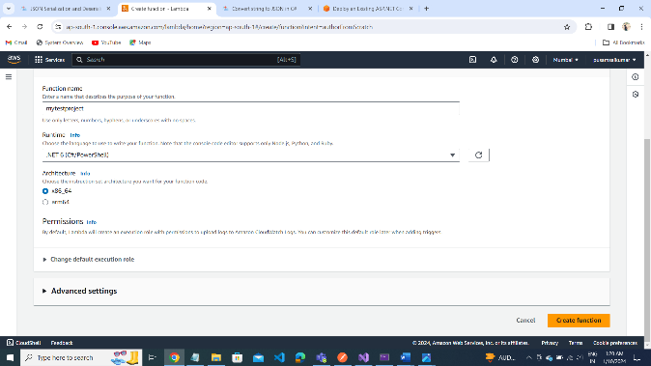

**Go to IAM Dashbord:**

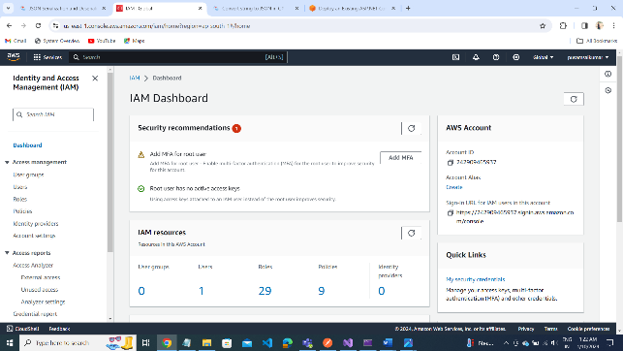

**Create User role:**

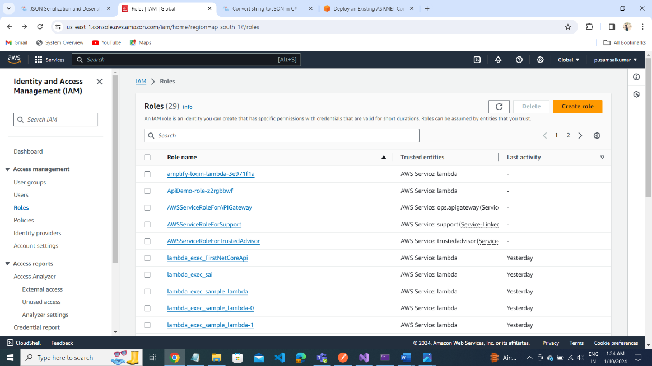

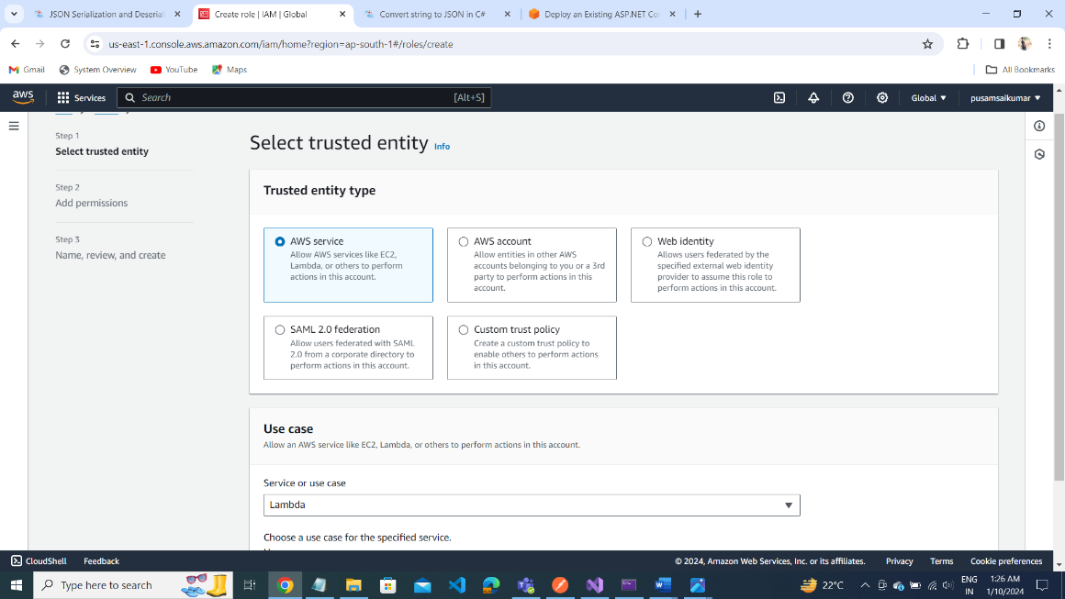

Select User role:

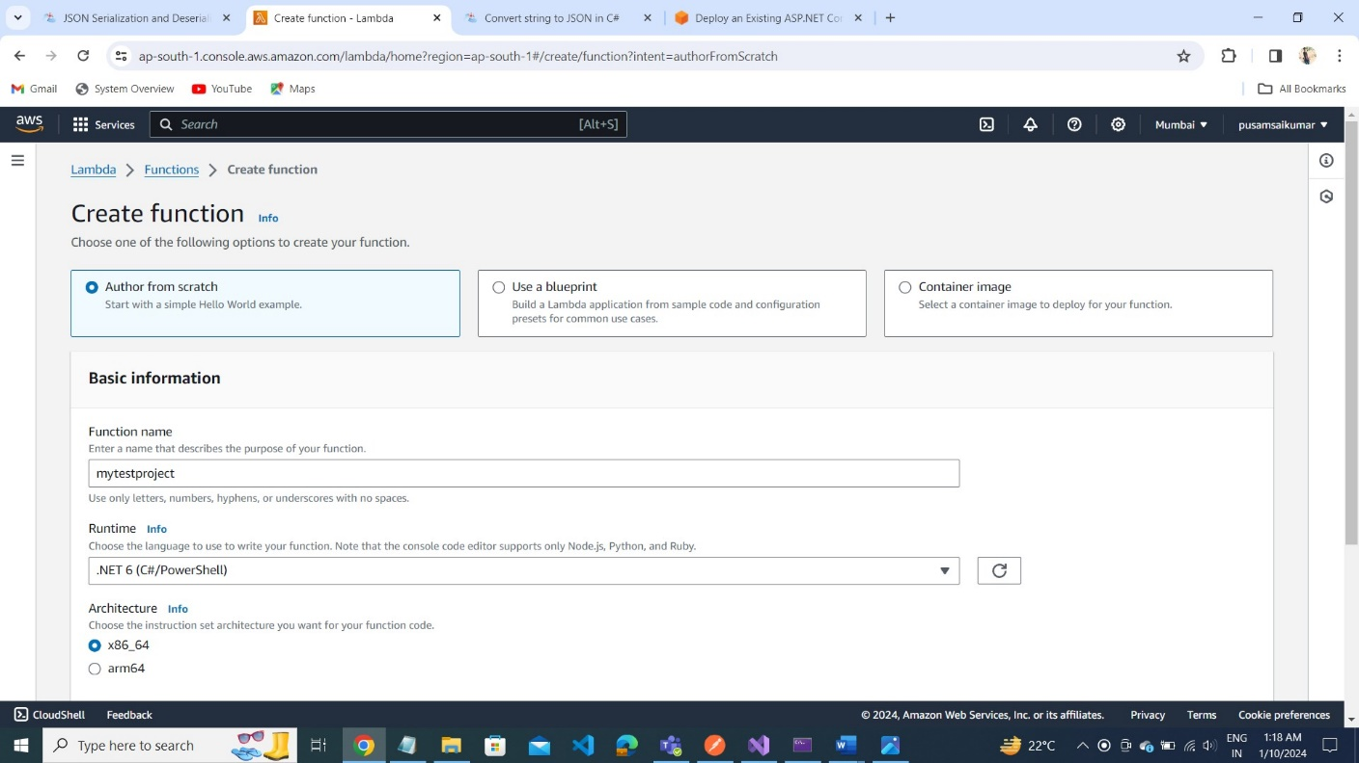

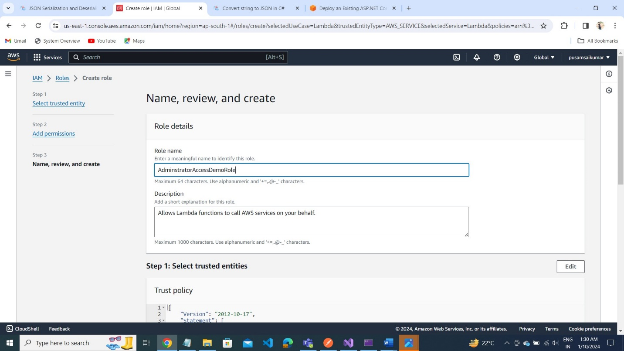

**Click on CreateRole**

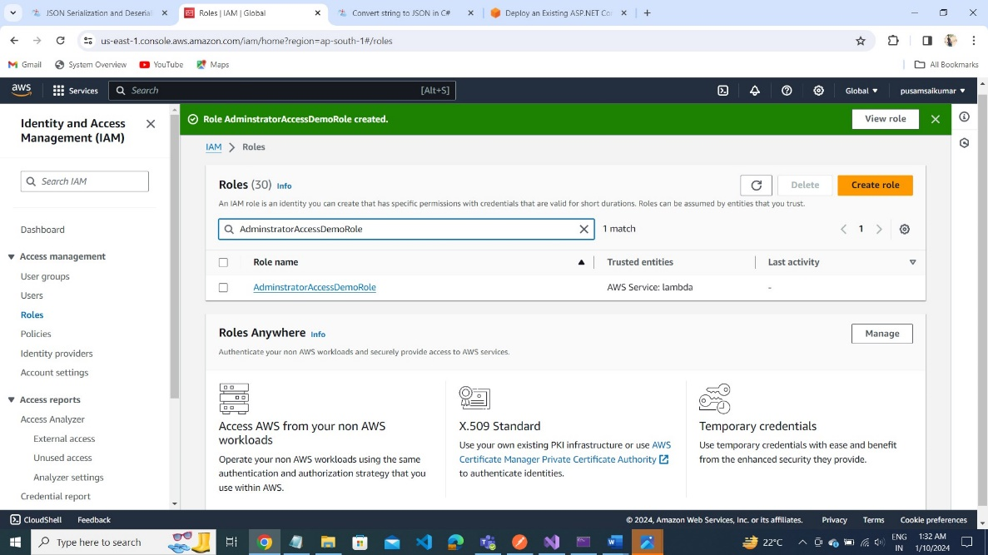

**8. Exposing the Web API using Amazon API Gateway**

**1. Configure proxy integration, and deploy the API**

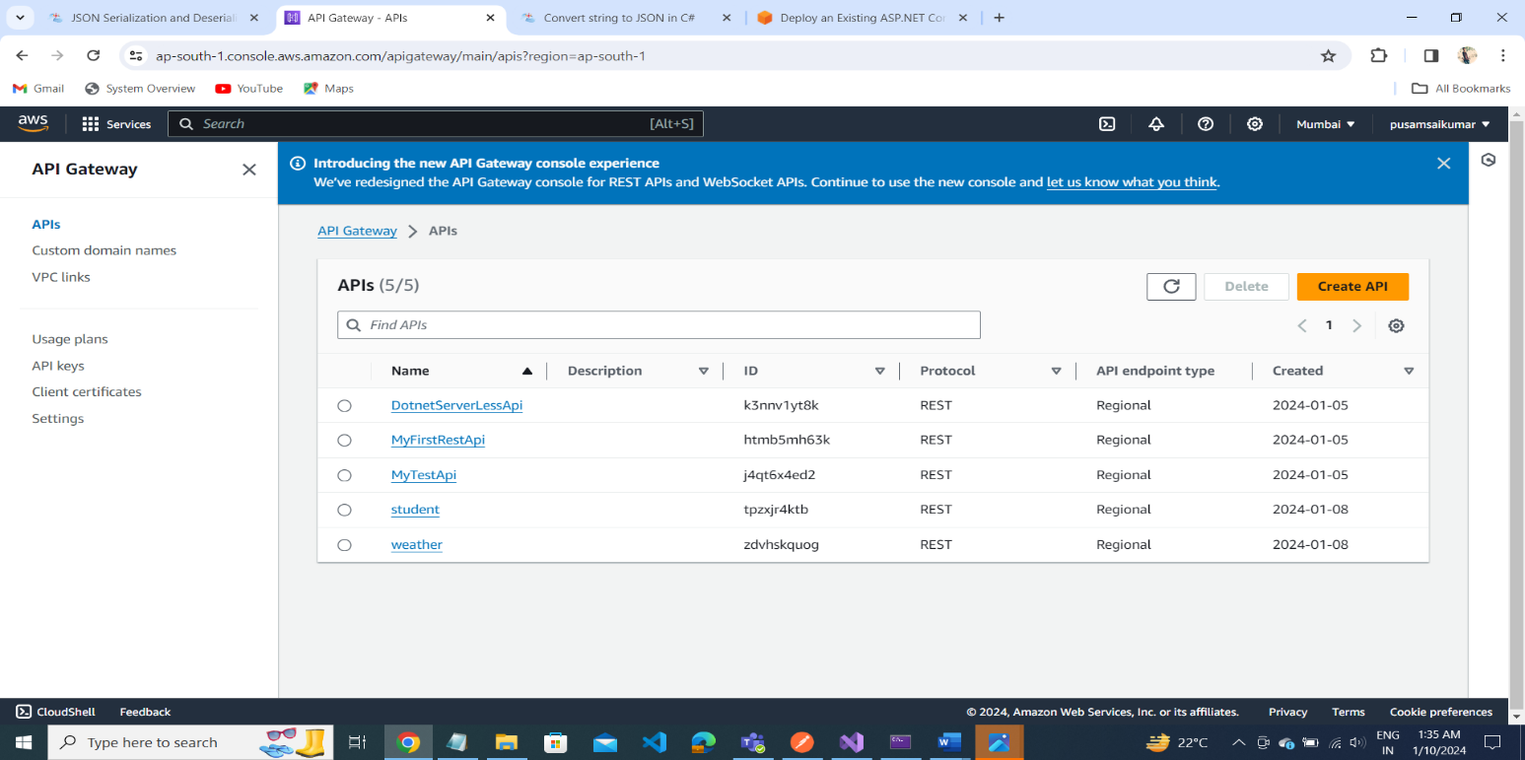

**Select RestApi: To build the api**

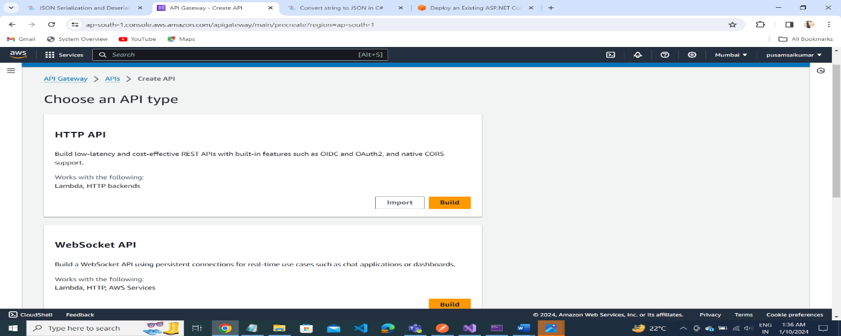

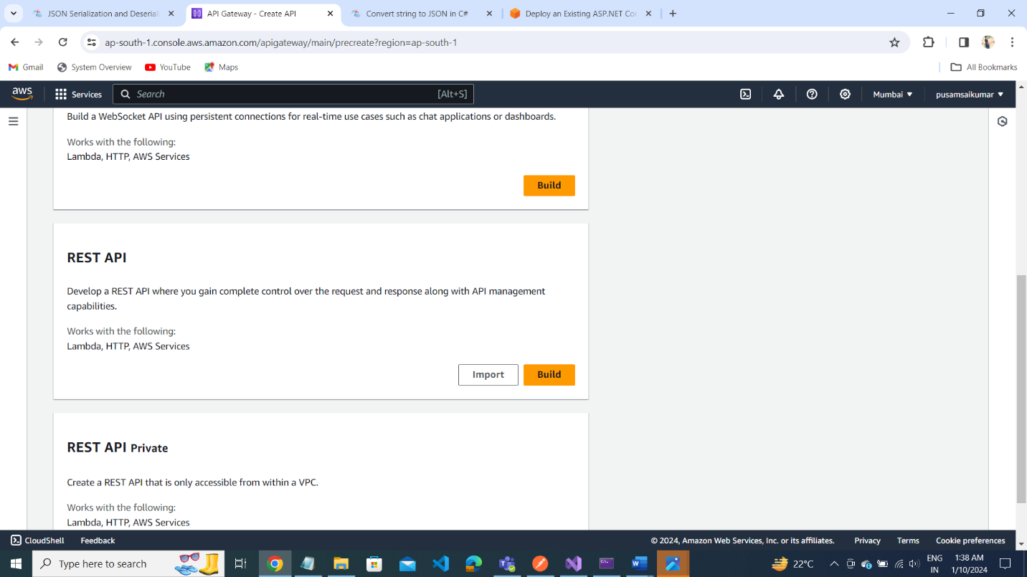

**Create API**

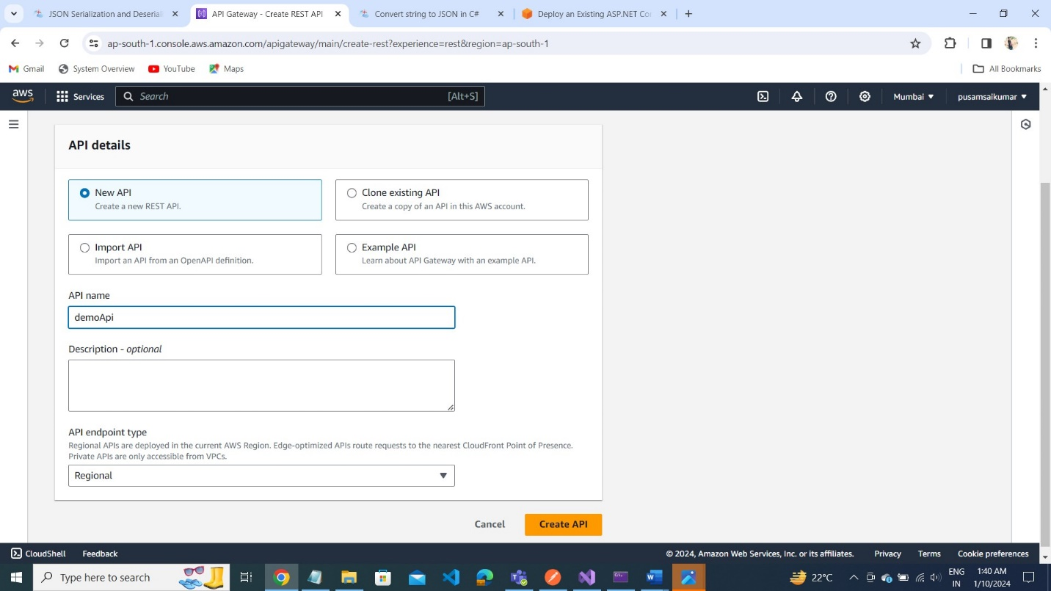

**STEP2: CreateResource**

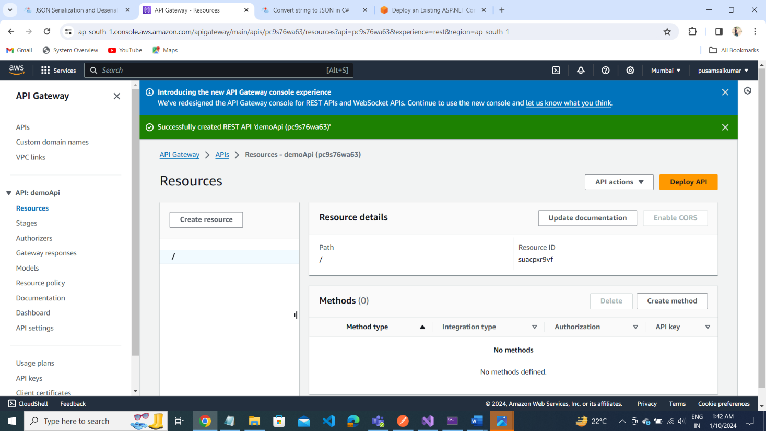

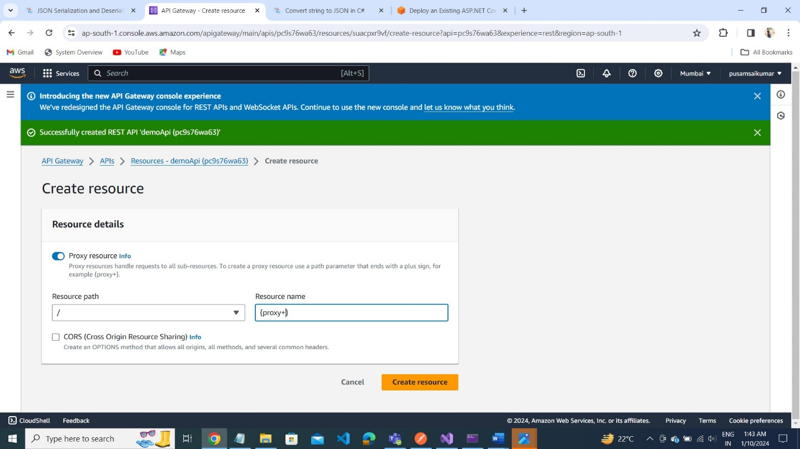

**ANY ---- Click on Any method to Create Integration.**

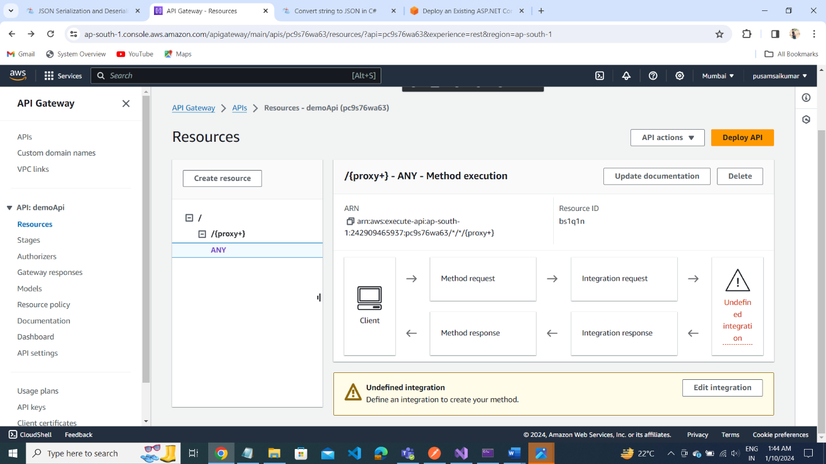

Edit Integration request

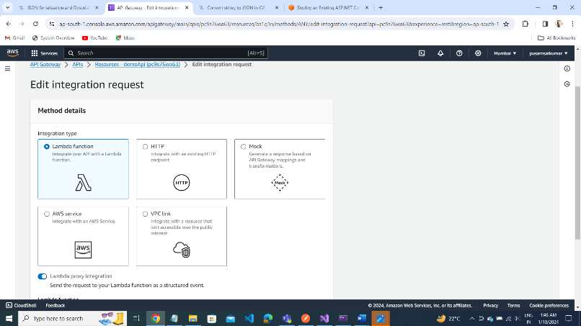

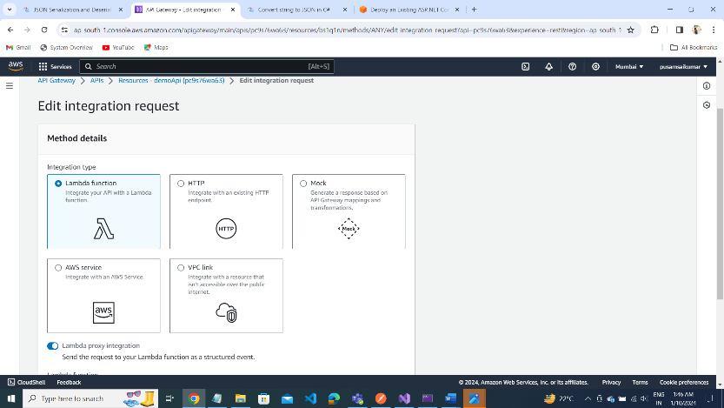

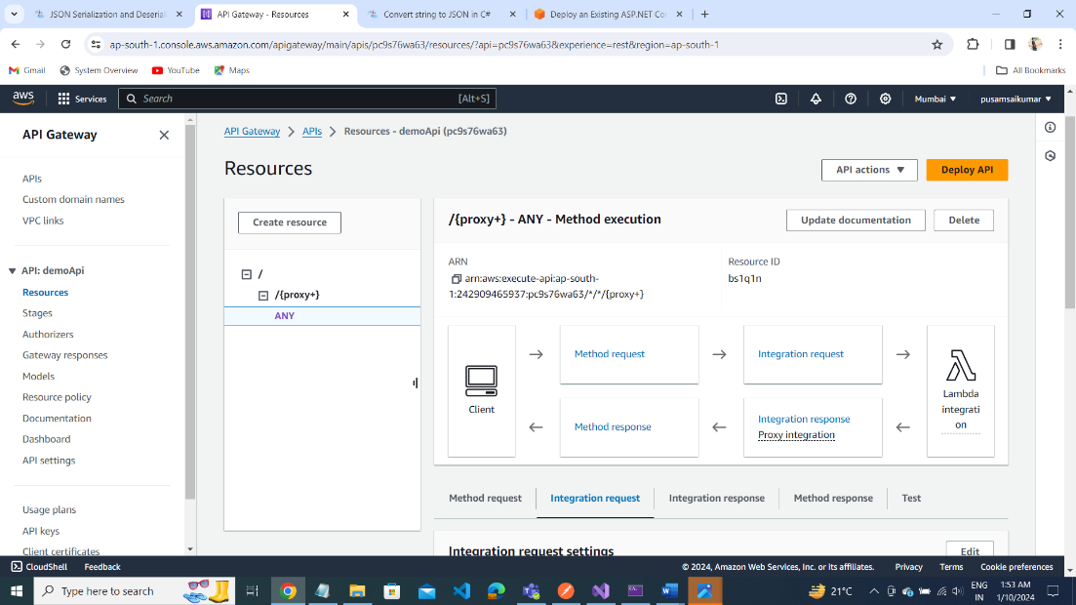

After Edit Integration Request

Test the api controller as per your project

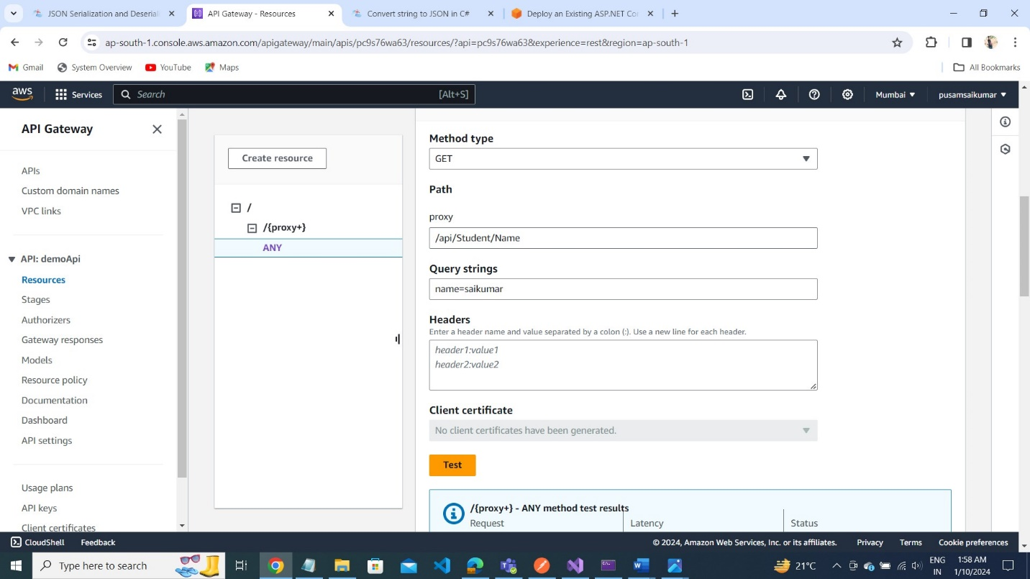

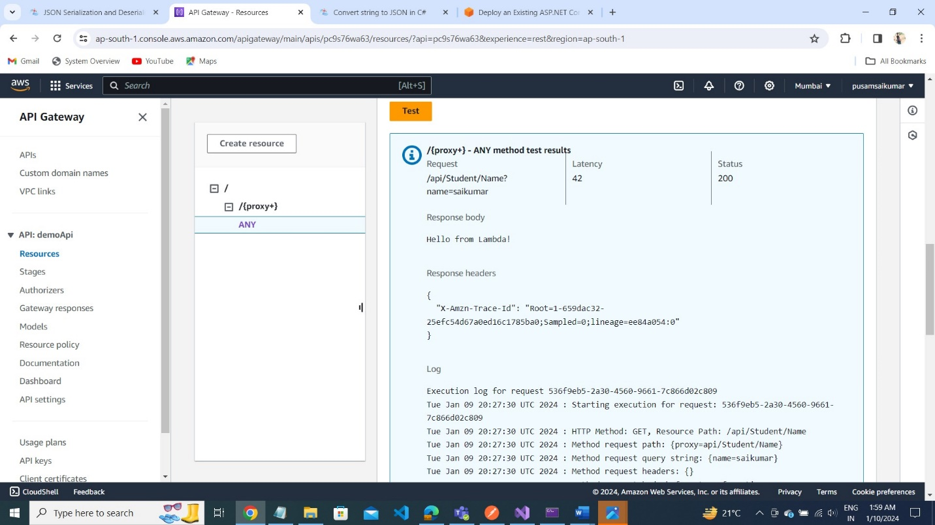

Deploy API

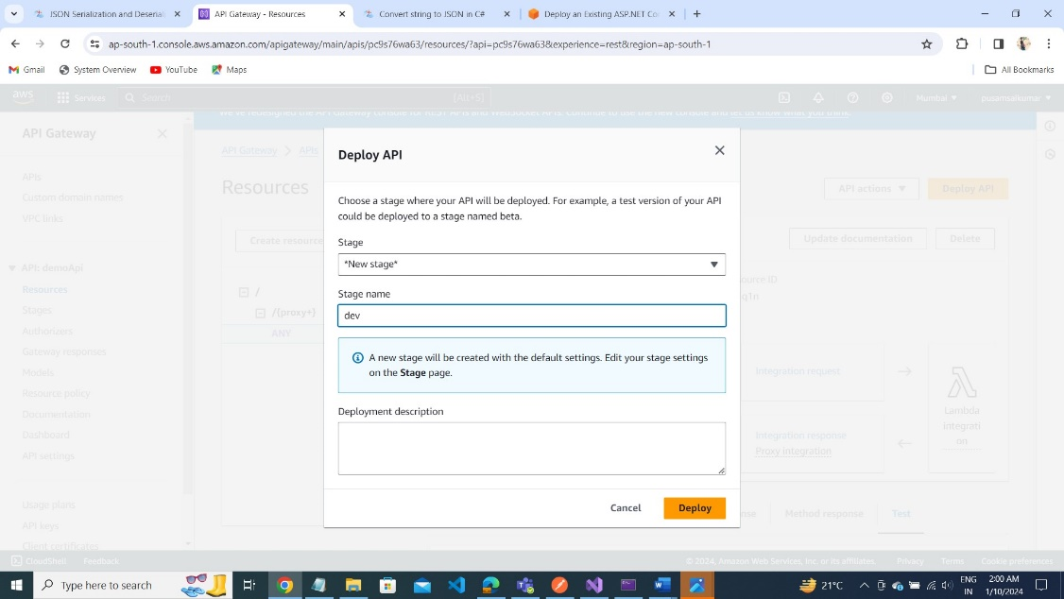

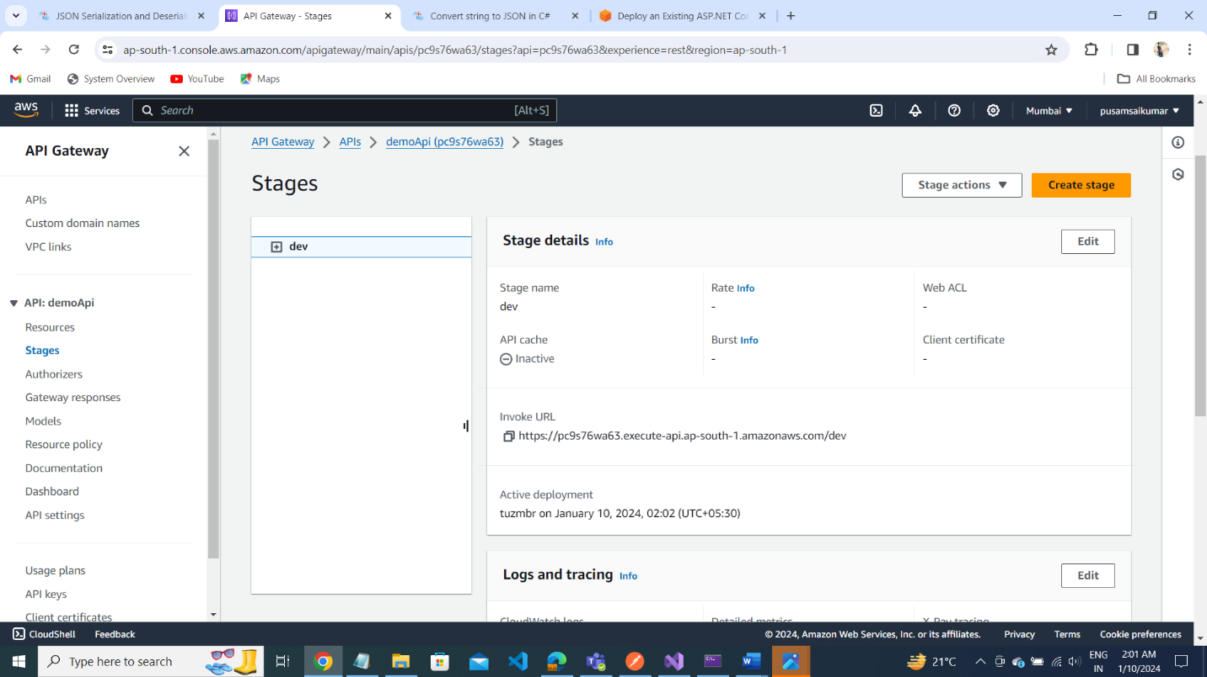

Store Secret Key Value Pairs into Secret Manager

Store New Secret:

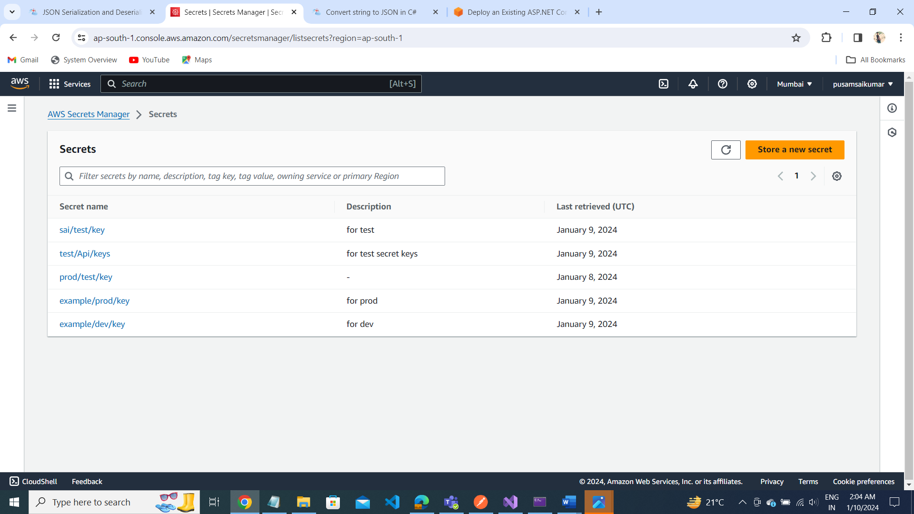

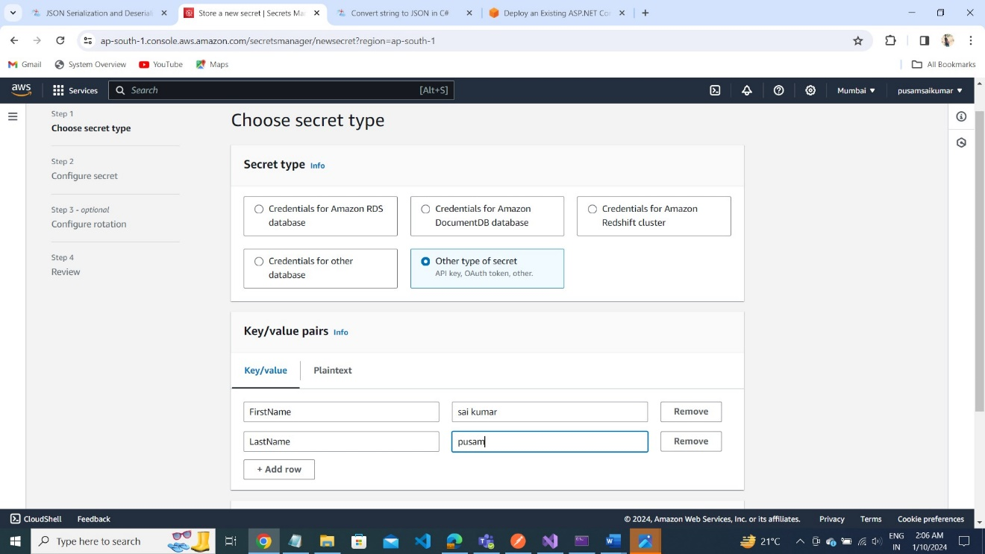

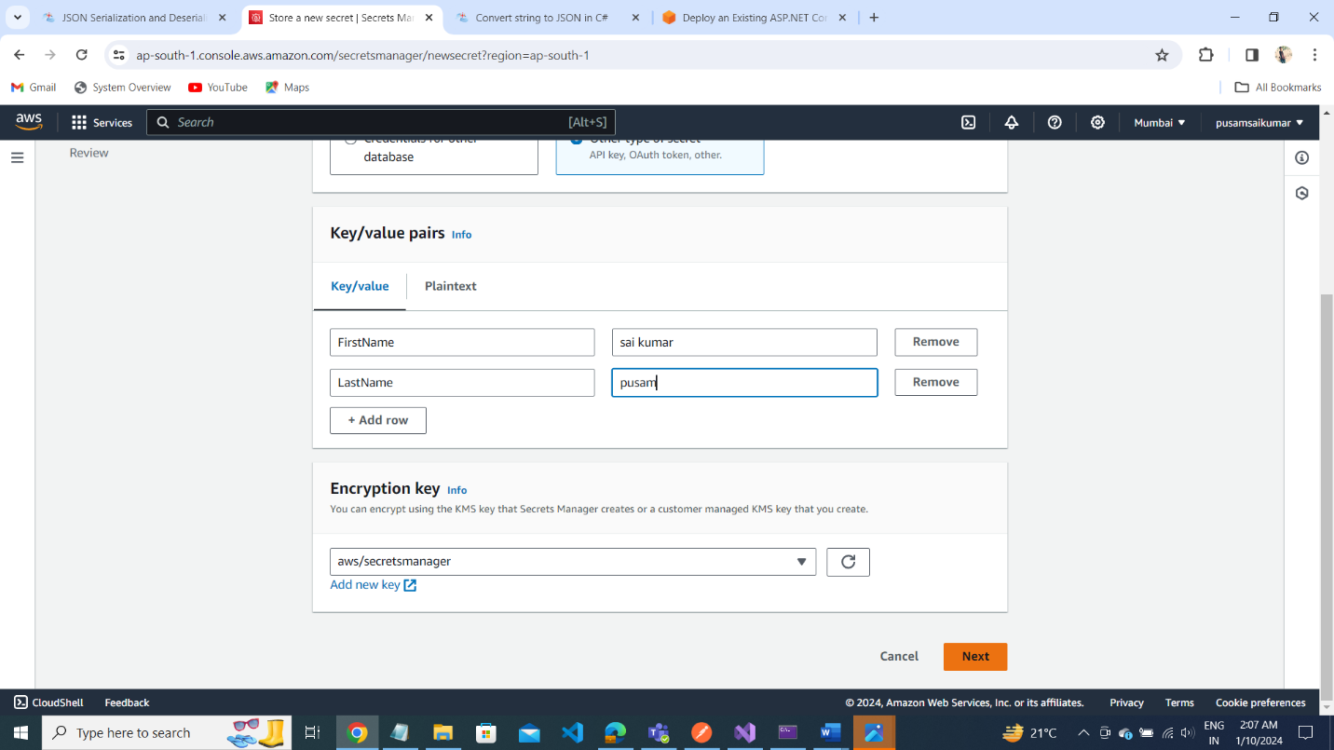

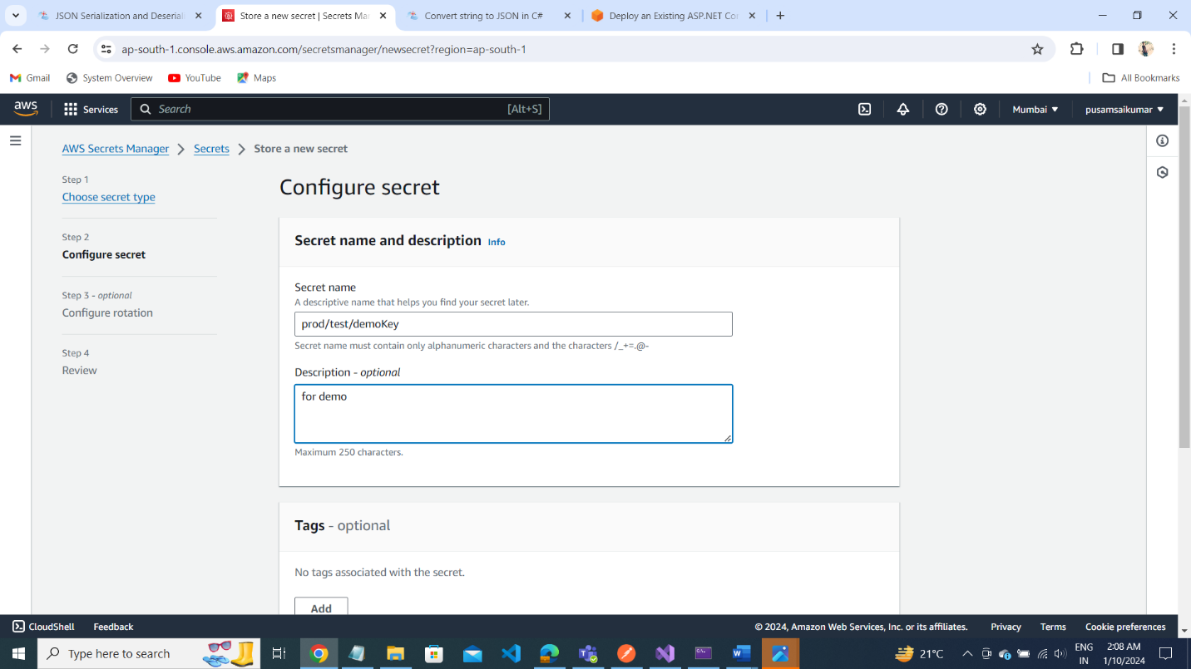

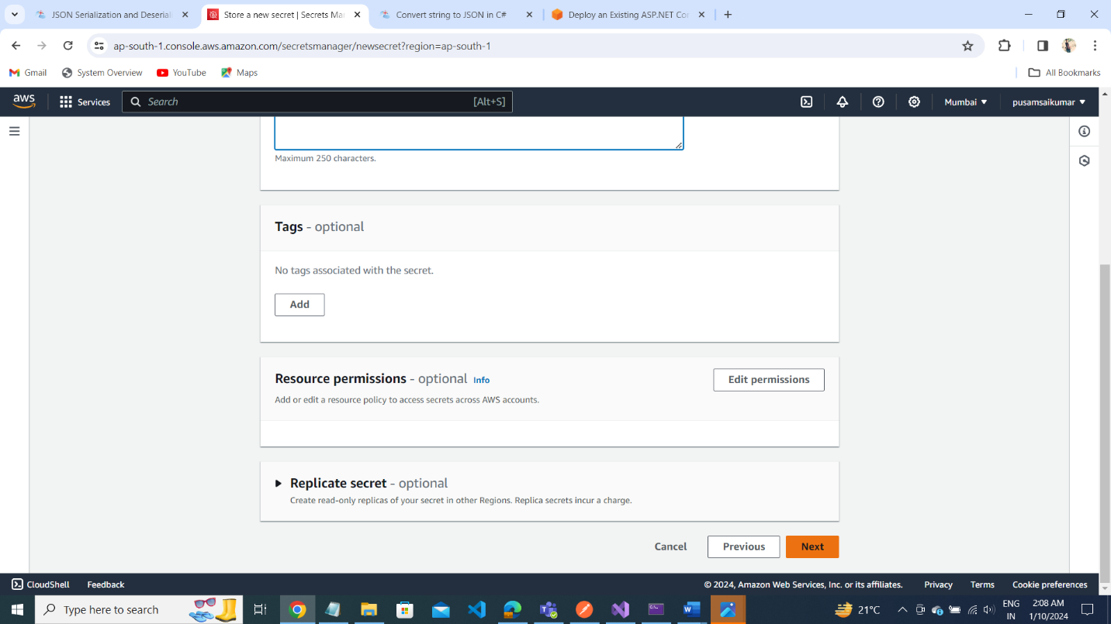

STEP2 and STEP3 GO With on Next button

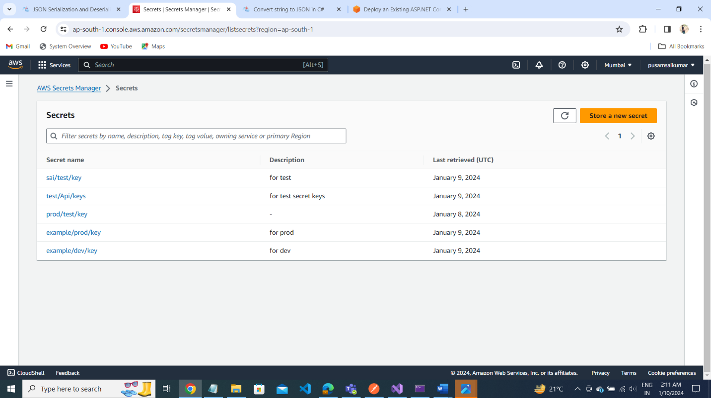

Create Policy for Secrets Manager:

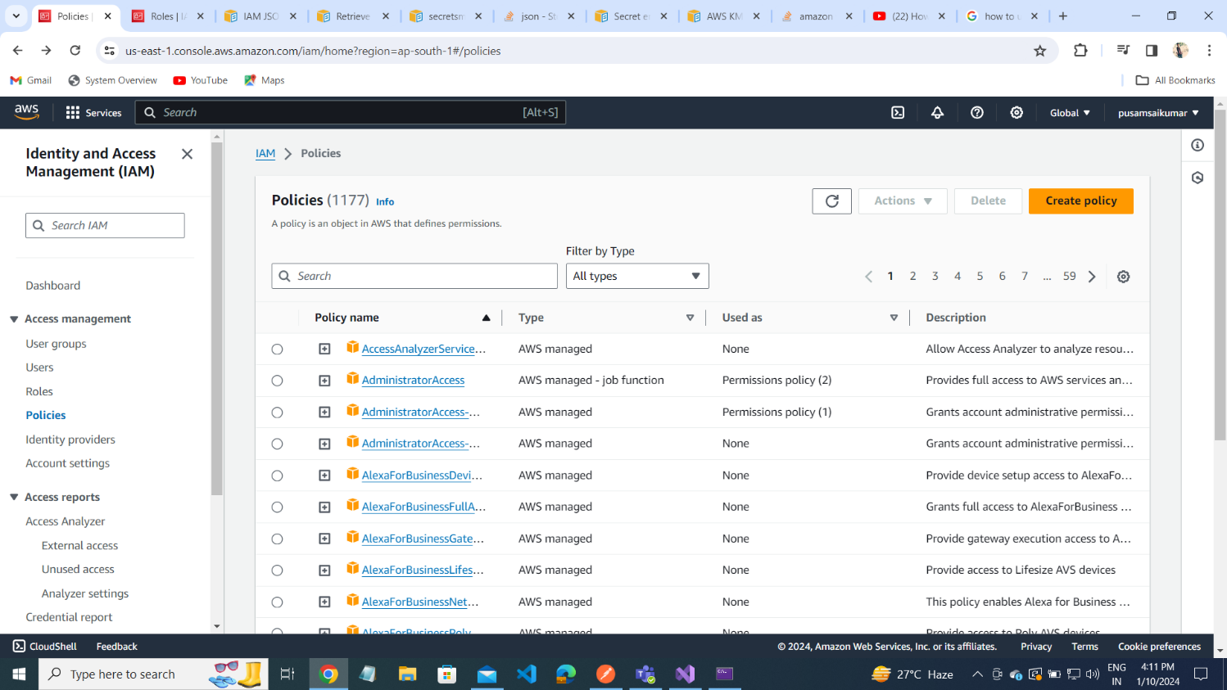

Select : Secrets Manager

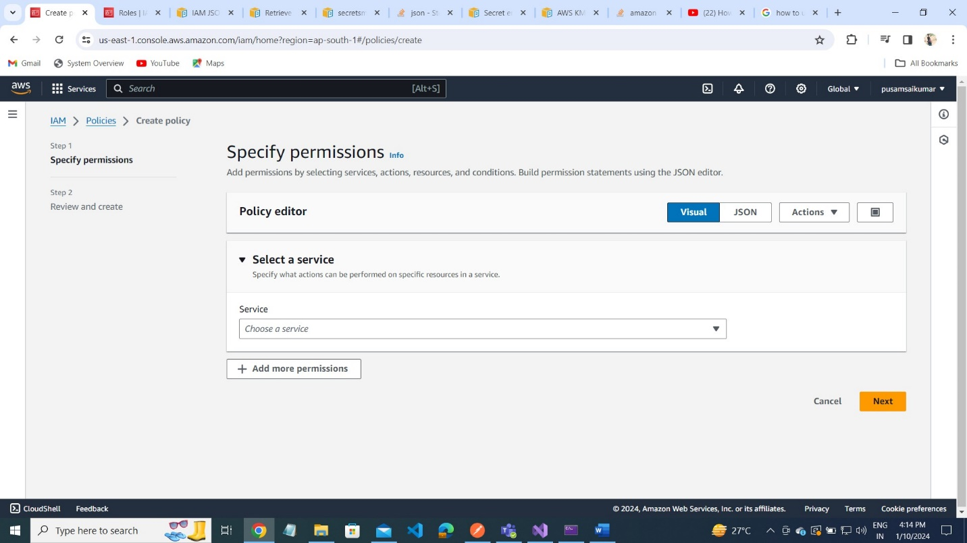

Select : Read actions

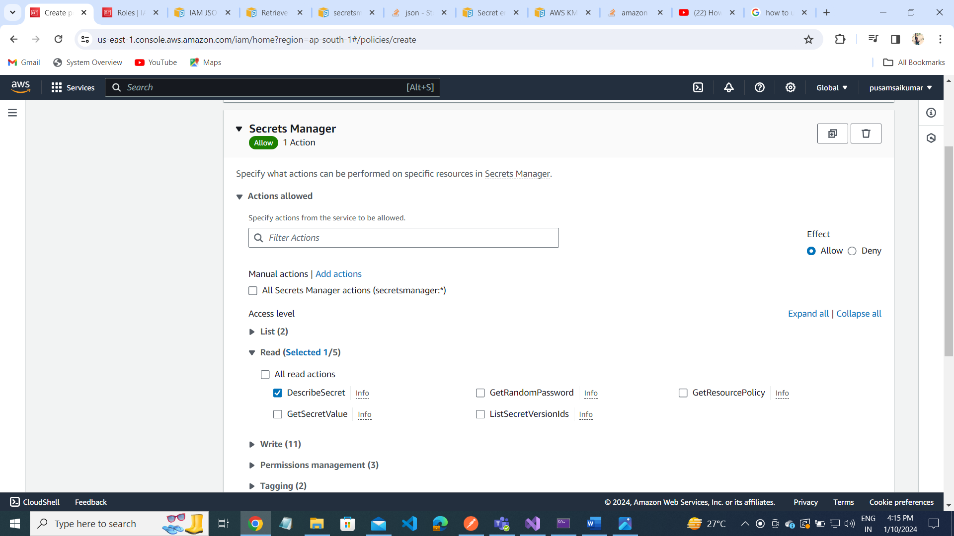

Add ARN(Amazon Resource Name):

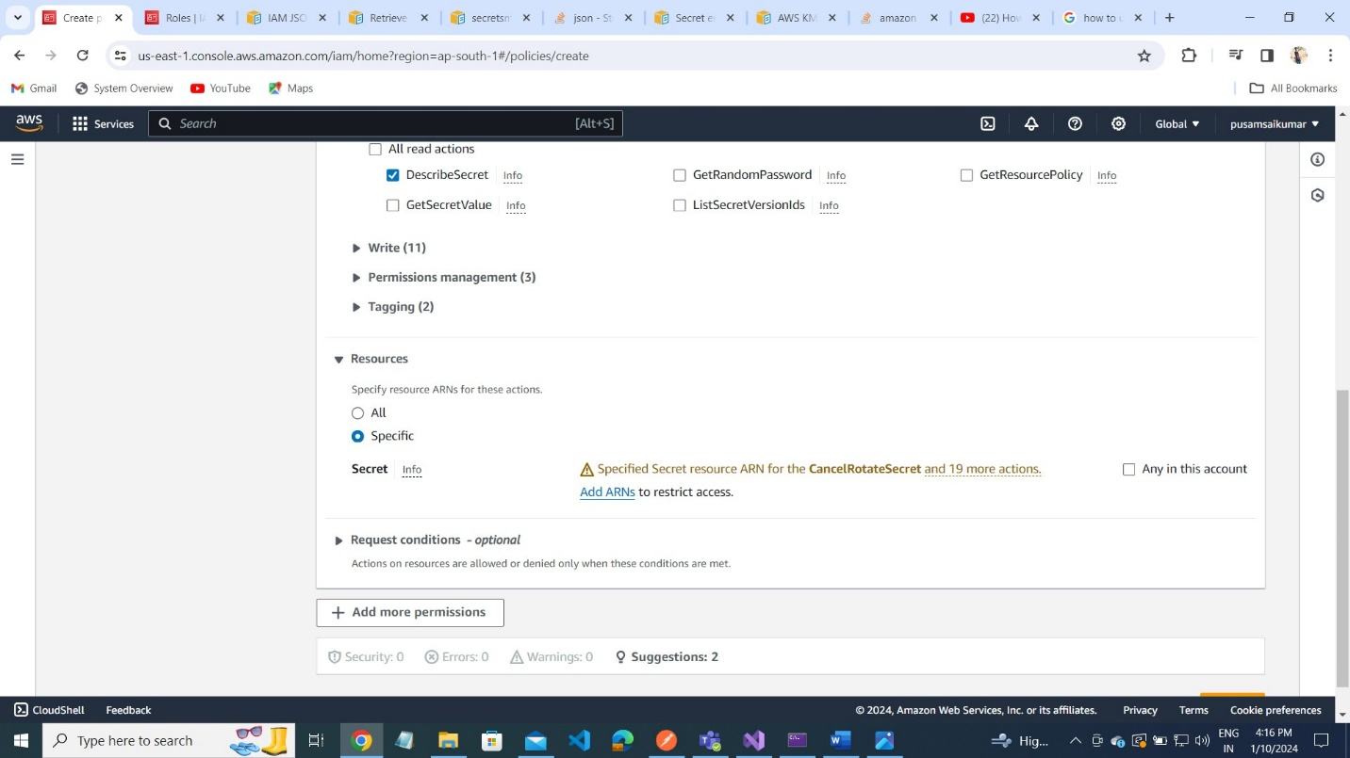

Select ARN keys from the Secrets Manager:

As follow below steps:

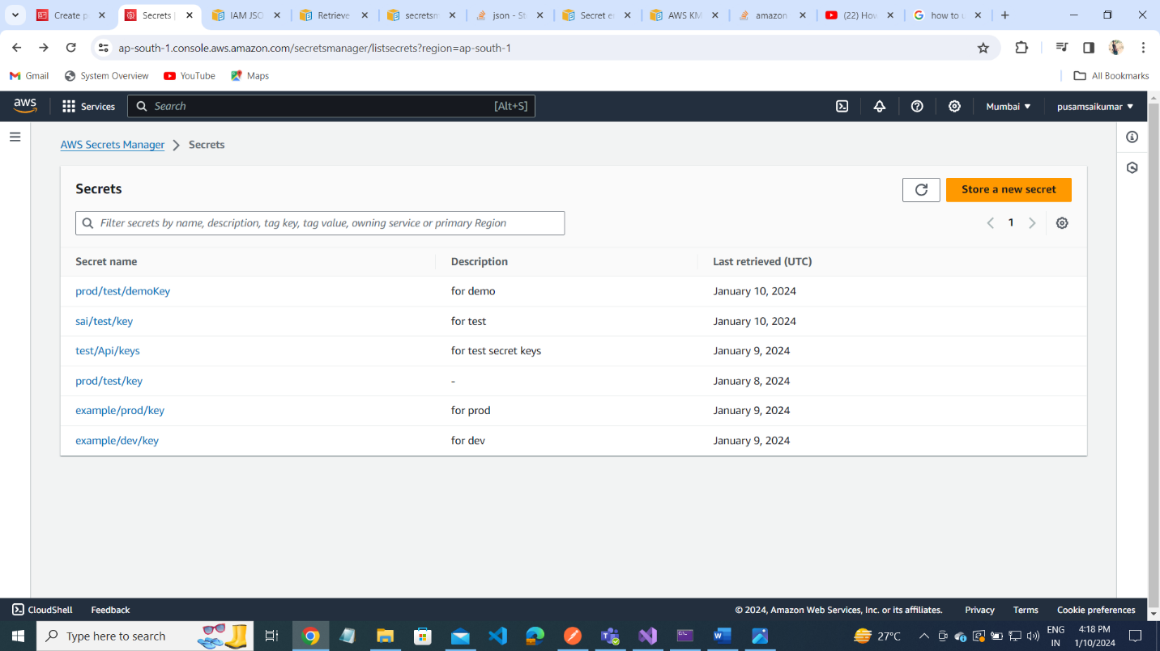

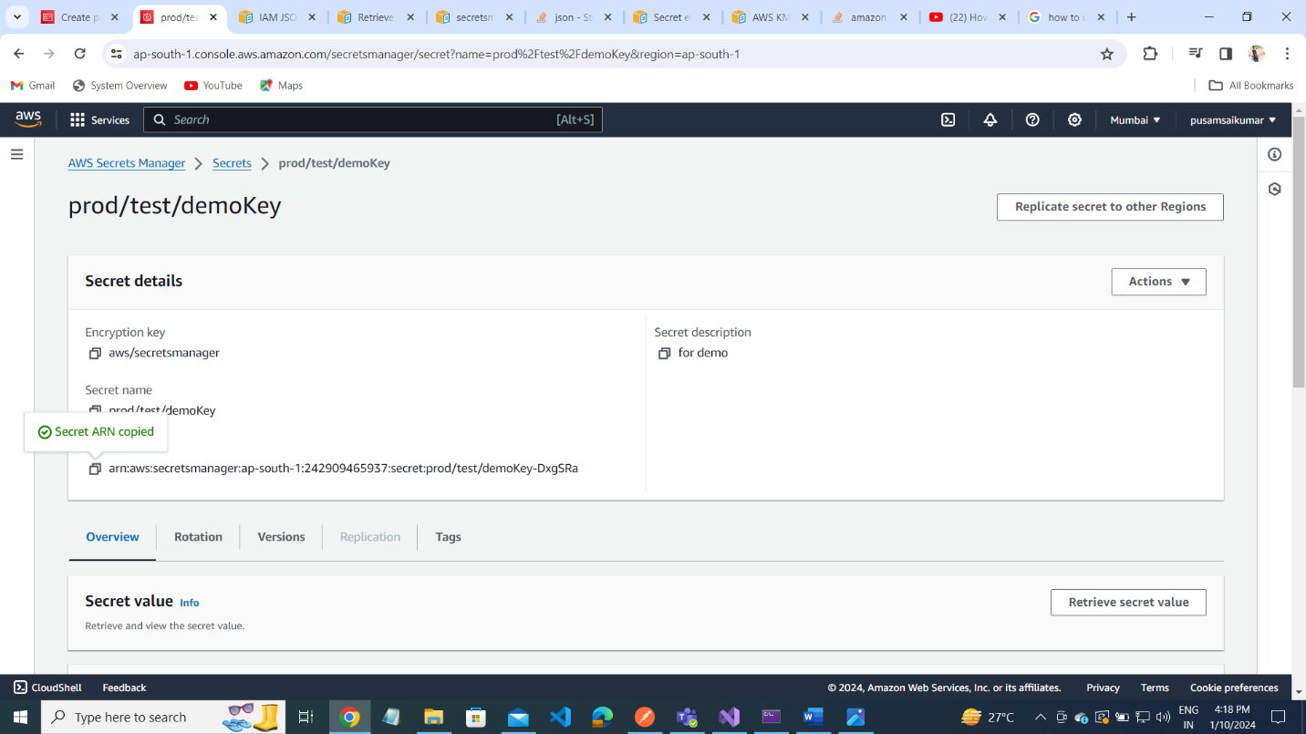

Paste the ARN key Inside a Resource ARN:

